Module 4 Portfolio Milestone (Design)
Platform-Based Development
CSC475-1 Winter 2025 Session A
Mr. Farhad Bari

Grant Brosovich
12/07/2025

Network Architecture Design
Overall Architecture:
- Client Application (Android, MVVM)
  - UI/UX Components (Jetpack Compose + Material 3)
  - ViewModels (StateFlow for reactive state management and data Persistence)
  - Repository Layer (Room)
  - Network Layer (Retrofit)
  - Image Loading Layer (Glide integration for recipe images)
  - Background Efforts (WorkManager)
- Server
  - Retrofit for REST API providing recipe, filter, and comment data
  - Database hosting recipe text, images, and metadata
General Architecture Diagram
UI Layer (Compose)
RecipeListScreen
RecipeDetailScreen
─────────────────────────────────
↓
ViewModel Layer
- StateFlow/MutableStateFlow
- Handles filtering, searching, comments, favorites
─────────────────────────────────
↓

Repository Layer
- RecipeRepository
─────────────────────────────────
↓ Local ↓ Remote
LocalDataSource (Room) RemoteDataSource (Retrofit)

Data Flow:
UI ViewModel Repository
Repository LocalDataSource (Room)
Remote API (Retrofit)
Remote API → DTOs → Domain Models → StateFlow → UI
Connectivity Strategy:
- Online-first fetch of recipes; fallback to cached DB
- Server calls made by Retrofit
- Glide handles image caching and efficient loading
All network communication will be performed by RetroFit. It handles HTTP requests, Serialization via Kotlin Serialization and API parsing responses (Azziza432, 2022).
Base URL:
const val BASE_URL = https://api.relishrecipes.com/
Below is an example of how network interface services will be handled and called.
interface RecipeApi {
@GET("recipes")
suspend fun getRecipes(
@QueryMap filters: Map<String, String>
): List<RecipeDto>
@GET("recipes/{id}")
suspend fun getRecipeDetails(
@Path("id") id: String
): RecipeDto
@POST("recipes/{id}/comments")
suspend fun addComment(
@Path("id") recipeId: String,
@Body comment: CommentDto
)
@POST("users/{userId}/favorites/{recipeId}")
suspend fun toggleFavorite(
@Path("userId") userId: String,
@Path("recipeId") recipeId: String
)
}
The following code snippet is an example API call using Kotlin and RetroFit.
viewModelScope.launch {
_uiState.value = UiState.Loading
try {
val data = repository.getRecipes(currentFilters)
_uiState.value = UiState.Success(data)
} catch (error: AppError) {
_uiState.value = UiState.Error(error.toString())
}
}
Network DTOs and Domain Models
DTOs and other Data Models will be built through Kotlin and utilize a variety of different data types and structures. The RecipeDTO will contain string variables for id, name, cuisine, image url, as well as String Lists for ingredients and instructions. Integer variables will be assigned to cookTime, prepTime, and servings. The Domain Model for the Recipe Class will have all these components as well as an Integer variable for totalTime, a Boolean variable for isFavorite, and another String List for userComments. In contrast the Room Entity will have the ingredients and instructions variables as a JSON string. Below is the example for the Domain Model data structure:
data class Recipe(
val id: String,
val name: String,
val cuisine: String,
val prepTime: Int,
val cookTime: Int,
val totalTime: Int,
val servings: Int,
val imageUrl: String,
val ingredients: List<String>,
val instructions: List<String>,
val isFavorite: Boolean,
val userComments: List<String>
Repository Structure and Sources
The Repository will utilize the Room DB for local instances and the RetroFit accessible server for remote requests. Error Handling will be used to fall back to the local resource should network access fail. The below snippet will be used to overwrite the local DB instance to provide the most up-to-date information while allowing for DB access from the last cached local instance.
class RecipeRepository(
private val local: RecipeDao,
private val remote: RecipeApi
) {
suspend fun getRecipes(filters: RecipeFilter): List<Recipe> {
return try {
val remoteData = remote.getRecipes(filters.toQueryMap())
local.insertRecipes(remoteData.map { it.toEntity() })
remoteData.map { it.toDomain() }
} catch (e: Exception) {
// Offline fallback
local.getFiltered(filters).map { it.toDomain() }
}
}
}
Error Handling
Error Handling will be conducted through individual classes and further, individual methods to allow for unique errors to be managed within a request anywhere in the application flow. An Abstract class will be used to assign errors for generalized cases and that abstraction will be customized within the individual class which references it. Abstract class example with example instance:
sealed class AppError {
object NetworkUnavailable : AppError()
data class Server(val code: Int) : AppError()
data class InvalidInput(val message: String) : AppError()
object Unknown : AppError()
}
Instance:
try {
val recipe = api.getRecipeDetails(id)
return recipe.toDomain()
} catch (e: HttpException) {
throw AppError.Server(e.code())
} catch (e: IOException) {
throw AppError.NetworkUnavailable
} catch (e: Exception) {
throw AppError.Unknown
}
Offline Support
Room DB will store the most recently cached version and the favorite status of each recipe as well as user comments. The cached version will be displayed immediately until network connectivity is reestablished. When connectivity is reestablished, the DB will be refreshed as user actions will be stored locally and synched after manual refresh.
Technical Specifications
As mentioned earlier, network communications will be handled through RetroFit and Kotlin Serialization will handle parsing controls. RetroFit will reduce boiler plate code, further managing code modularity, as well as allowing for quick and easy conversion to Kotlin-readable objects and responses (Kramer, 2024). Glide will be used as the image loading layer to help reduce caching impacts and allow for scrolling, sizing, and image customizing for display within the UI (Saketkumr, 2025).
Authentication is handled via token storage and referencing using RetroFit call wrappers. Tokens will be stored in Kotlin’s ‘EncryptedSharedPreferences’.
Data Persistance is handled with Room Database and DataStore Preferences for user settings while WorkManager will be used for background task management.
Testing will be done through unit tests for each layer of application interaction. The ViewModels will be tested for display and accessibility. Then repository logic will be confirmed so that all data persistence, database accesses and card details are accurate. DTO, Domain, an entity mappers will be finalized and API responses will be tested through MockWebServer. Finally, UI tests for user interactions, data flow, network requests and DB interactions are efficient and effective. A Final comprehensive test will be conducted with a small control user group with no previous experience with the application to ensure user-friendly error-handling and application resiliency works.

Class Diagrams
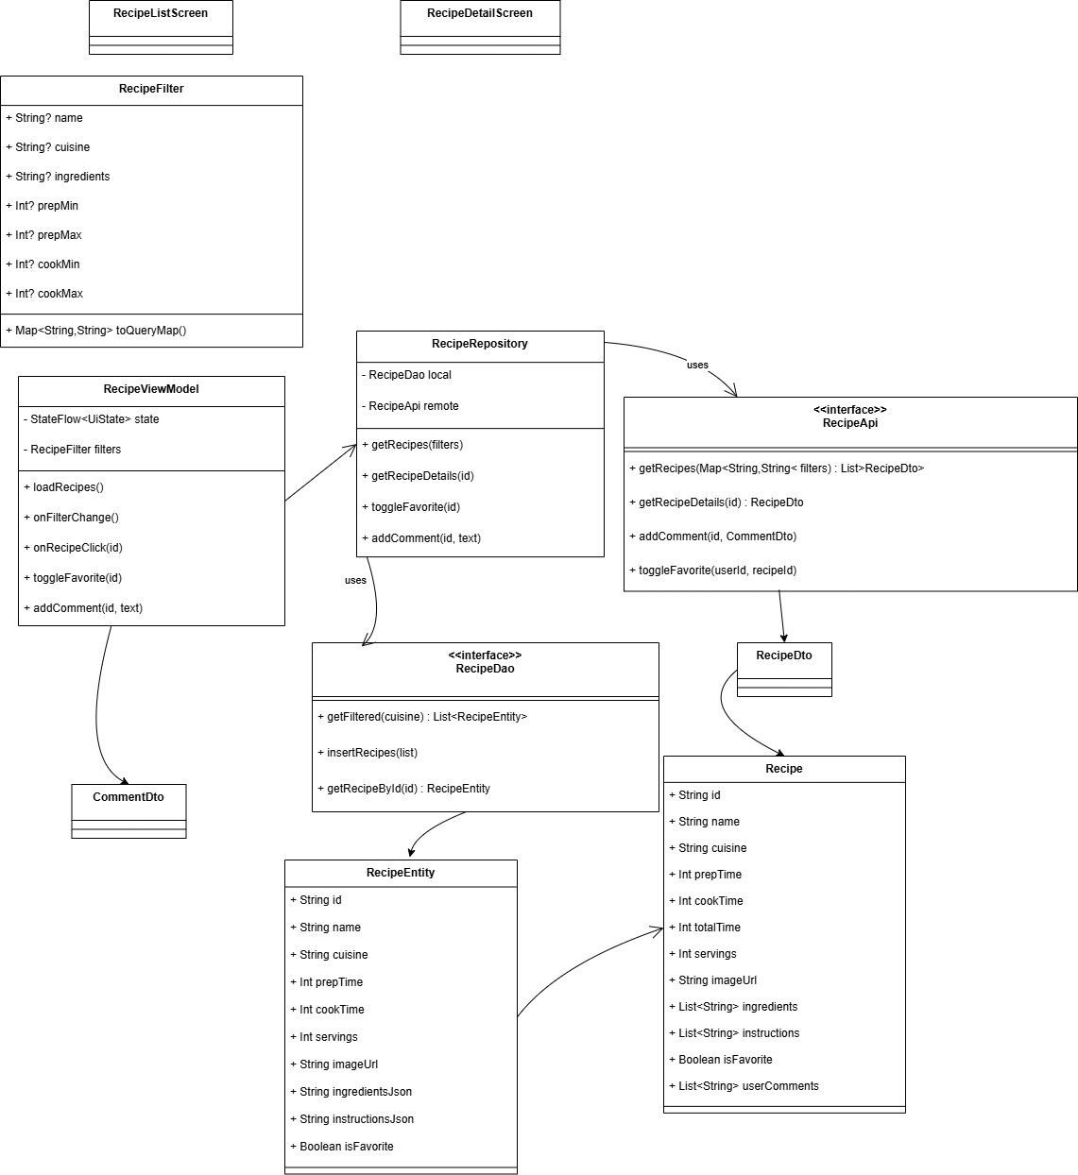
References:
Azziza432. (2022, April). Kotlin handle retrofit request with coroutines. stackOverflow. December 7, 2025, https://stackoverflow.com/questions/66256991/kotlin-handle-retrofit-request-with-coroutines
Kramer, N. (2024, May 14). Retrofit Tutorial for Android Beginners. Daily.dev. December 7, 2025, https://daily.dev/blog/retrofit-tutorial-for-android-beginners#:~:text=using%20Retrofit%20annotations.-,Defining%20Endpoints%20with%20Annotations,parameters%20required%20for%20the%20request.&text=In%20this%20example%2C%20the%20@GET,@DELETE%20%2C%20and%20@HEAD%20
Saketkumr. (2025, February 4). How to use Glide Image Loader Library in Android apps?. GeeksforGeeks. https://www.geeksforgeeks.org/android/image-loading-caching-library-android-set-2/

